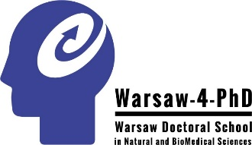
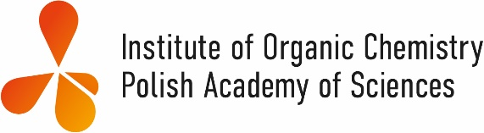
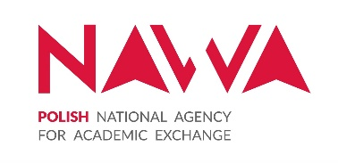

Warsaw Doctoral School in Natural and Biomedical Sciences and the Institute of Organic Chemistry PAS cordially invites you to advanced lecture series:

Radical Reactions for Organic Synthesis
given by
Prof. Samir Z. Zard (École Polytechnique, Palaiseau, France)

Samir Z. Zard was born in 1955 in Ife, Nigeria. His training as a chemist started at the American University of Beirut, then at Imperial College, London, and finally at the Université Paris-Sud, Orsay, France, where he received his doctorate in 1983 under the supervision of Professor Sir Derek Barton. His main research concerns the study and development of new reactions and processes, with a special interest in radicals, organosulfur derivatives, alkynes and nitro compounds. In addition to a number of academic awards, he received in 2007 the Croix de Chevalier de la Légion d’Honneur.

Lecture 1 – Tuesday, April 11, 2023 – 9 a.m. – conference room IOC PAS, Warsaw, Kasprzaka 44/52
Introduction and General Principles: Chain Reactions Based on Stannane Chemistry
A brief history of radicals. The structure and reactivity of radicals. Time scales: the importance of reaction rates. A general comparison with ionic reactions. Keeping the concentration of radical species low: chain reactions. A simple chain reaction based on organotin hydrides. The Barton-McCombie deoxygenation. Additions to olefins: general considerations. Intermolecular additions: rates and frontier orbital considerations (polar effects), regio- and stereochemistry. Intramolecular additions: rates, regio- and stereochemistry. Some synthetic applications (including nitrogen and oxygen centred radicals).
Further Chain Reactions of Stannanes
Radical rearrangements. Ring opening: rates, regiochemistry and stereoelectronic effects. Synthetic applications. Migrations of functional groups (aryl, vinyl, nitrile, etc.). Applications to ring expansions and contractions. Fragmentation processes: general considerations. Allylstannanes and related derivatives.

Lecture 2 – Thursday, April 13, 2023 – 11 a.m – conference room IOC PAS, Warsaw, Kasprzaka 44/52
Tin-free modifications
Tris(trimethylsilyl)silane and hypophosphorous reagents. Further reflections on the Barton-McCombie deoxygenation.
Organomercury Hydrides
General considerations. Chain reactions with mercury hydrides.
Radical Decarboxylations and Related Reactions
The Barton decarboxylation reaction: the basic process. An improved Borodin-Hunsdiecker reaction. Further variations. C-C bond formation.

Lecture 3 – Tuesday, April 18, 2023 – 11 a.m. – conference room IOC PAS, Warsaw, Kasprzaka 44/52
Atom and Group Transfer Reactions
Kharasch type processes. Degeneracy and the lifetime of the intermediate radicals. Hydrogen atom transfer from thiols and activated C-H bonds. Halogen atom transfer. Transfer of xanthates.
Non-Chain Processes
The persistent radical effect. Photolysis of nitrites (the Barton reaction). Mimicking vitamin B12: the chemistry of organocobalt derivatives. Applications to polymers.

Lecture 4 – Wednesday, April 19, 2023 – 9:30 a.m. – conference room IOC PAS, Warsaw, Kasprzaka 44/52
Redox Processes
Electron transfer processes. Generation of radicals by oxidation: general reaction scheme. Oxidations with metal salts (Mn^{III}; Ce^{IV}; Pb^{IV}; Ag^{II}; Cu^{II}; Fe^{III}). Combinations of metal salts. Generation of radicals by reduction: general reaction scheme. Reductions with metals and metallic salts (Cr^{II}; Sm^{II}; Ti^{III}; Fe^{II}; Cu^{I}). Photoredox catalysis.

OPEN LECTURE – Friday, April 14, 2023 – 10 a.m. – aula IOC/ICP PAS, Warsaw, Kasprzaka 44/52
Lecture: ” Radical Alliances. Solutions and Opportunities for Organic Synthesis”

Registration at aleksandra.butkiewicz@icho.edu.pl

This event is supported by the Polish National Agency for Academic Exchange, grant no.
BPI/STE/2021/1/00034/U/00001

